Recruits' Ineligibility Tests the Military

David Monzon, who lost over a hundred pounds and plans to join the Army, pours a cup of water after jogging near his home in Los Angeles. Patrick T. Fallon for The Wall Street Journal
By
Miriam Jordan
June 27, 2014 6:59 p.m. ET
More than two-thirds of America's youth would fail to qualify for military service because of physical, behavioral or educational shortcomings, posing challenges to building the next generation of soldiers even as the U.S. draws down troops from conflict zones.
The military deems many youngsters ineligible due to obesity, lack of a high-school diploma, felony convictions and prescription-drug use for attention-deficit hyperactivity disorder. But others are now also running afoul of standards for appearance amid the growing popularity of large-scale tattoos and devices called ear gauges that create large holes in earlobes.

Brittany Crippen, from Fort Worth, Texas, was disqualified because of a tattoo on the back of her neck. Mei-Chun Jau for The Wall Street Journal
A few weeks ago, Brittany Crippen said she tried to enlist in the Army, only to learn that a tattoo of a fish on the back of her neck disqualified her. Determined to join, the 19-year-old college student visited a second recruiting center in the Dallas-Fort Worth area and was rejected again.
Apologetic recruiters encouraged her to return after removing the tattoo, a process she was told would take about year. "I was very upset," Ms. Crippen said.
The military services don't keep figures on how many people they turn away. But the Defense Department estimates 71% of the roughly 34 million 17- to 24-year-olds in the U.S. would fail to qualify to enlist in the military if they tried, a figure that doesn't even include those turned away for tattoos or other cosmetic issues. Meanwhile, only about 1% of youths are both "eligible and inclined to have a conversation with us" about military service, according to Major Gen. Allen Batschelet, commanding general of U.S. Army Recruiting Command.

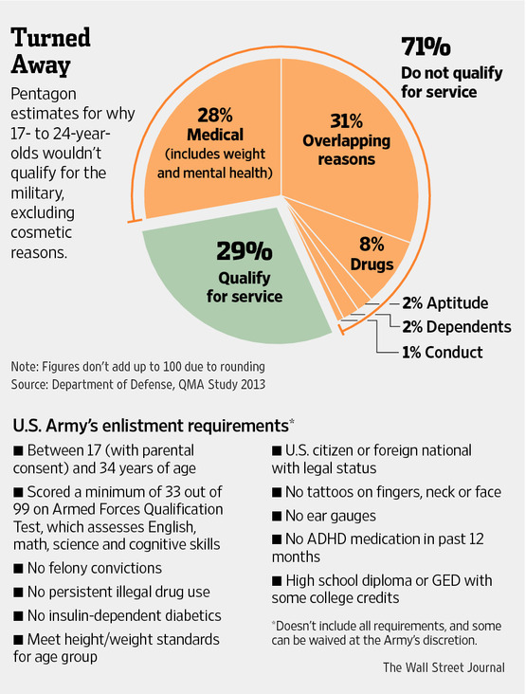Comparable data aren't available for earlier years because the Pentagon began tracking eligibility only recently. But experts said seniors graduating from high school this year face the longest odds to qualify for military service since the draft was abolished in 1973.
"The quality of people willing to serve has been declining rapidly," said Gen. Batschelet.
Each year, about 180,000 young men and women successfully volunteer for America's active-duty forces. An additional 110,000 join the services' reserve and National Guard units. Individual services manage their own recruiting and have the authority to grant waivers to applicants who don't meet broad standards.
When the military faced escalating foreign engagement in recent years, recruiting standards were loosened: In 2007, only 79% of those who enlisted in the Army had completed high school, compared with 90% in 2001, while the Army also accepted recruits with more excess body fat during the height of the Iraq war.
"We have not adopted a zero-defect mentality. We evaluate each applicant from a whole-person perspective," said Nathan Christensen, a Defense Department spokesman, who added that military services have been meeting their recruiting targets in recent years.
To some degree, that has been aided by enlistment bonuses. From 2000 to 2008, the Defense budget for enlistment bonuses more than doubled to $625 million, and it jumped more than 50% to $1.4 billion for selective re-enlistment bonuses, according to a Rand Corp. analysis.
Obesity, the single biggest reason for disqualifying new recruits, and other obstacles, such as poor educational attainment, led 90 retired military leaders in 2009 to form Mission: Readiness, a nonprofit aimed at raising awareness and seeking solutions. The group has lobbied state and federal officials to improve nutrition in schools and expand access to early education.
"We're trying to make decision makers see this is a national-security matter—and they need to prioritize it," said retired Major Gen. Allen Youngman. In the past, he said, "a drill sergeant could literally run the weight off a soldier as part of the regular training program," but now, "we have young people showing up at the recruiter's office who want to serve but are 50 or more pounds overweight."
About a quarter of high-school graduates also can't pass the Armed Forces Qualification Test, which measures math and reading skills, Gen. Youngman said. "They aren't educationally qualified to join the military in any capacity, not just the high-tech jobs," he said.
U.S. Army First Sgt. James Sawyer, who heads recruiting across a swath of Los Angeles County, said tattoos have become the most common cosmetic reason that applicants are disqualified. The Army already banned tattoos on the face, neck and fingers, but according to regulations in effect May 1, soldiers also can't have more than a total of four visible tattoos below the elbows and knees, and tattoos must be relatively small. The goal of the tattoo rules is to maintain a professional-looking Army, Sgt. Sawyer said. He added that "the average person in California has a tattoo."
Gabby Guillen, director of tattoo removal at Homeboy Industries, a Los Angeles nonprofit that provides services to former gang members, said that "on a daily basis, people come in saying they don't qualify for the military because of their tattoos. They have visible tattoos. Sometimes it's behind the neck area, on the hands, face, ears."
Sgt. Sawyer's El Monte, Calif., recruiting center serves towns with a total population of 325,000 people. It enlists 10 to 15 people a month. "A lot of times, we don't even get to the interview stage," said the sergeant on a recent afternoon as some would-be soldiers dropped in.
One young man showed up with two gaping holes in his earlobes, the result of wearing ear gauges. "Come back when they're closed," the recruiter said, after jotting down the applicant's information.
David Monzon, a 23-year-old East Los Angeles man, said he had long wanted to join the Army but wasn't able to enlist after graduating; at 5 feet 6 inches tall, he weighed 300 pounds. After researching weight-loss programs, Mr. Monzon eliminated pizza, chili-cheese fries and other fatty foods from his diet, and he began riding his bike everywhere.
In February, Mr. Monzon walked into the recruiting center weighing 210 pounds. Sgt. Sawyer told him he was impressed but that he still needed to drop a few more pounds.
"I was pretty confident I would make it," Mr. Monzon said. He did. Now 190 pounds, Mr. Monzon is heading to South Carolina for basic training in September.
Ms. Crippen, meanwhile, said she was still considering whether to remove her fish tattoo, the only one of four tattoos she has that is problematic. "My parents said they'll pay for it, but right now I really don't know what I'll do," she said. "My tattoo isn't offensive."

